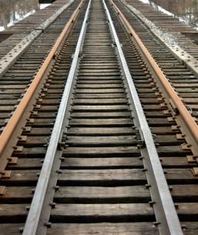
ALLEN & ALLEN MODEL RAILROADING
We build HO, O, G scale systems. We build you in joy.

To whom it may concern,

My name is Joel Allen II, I am the founder of Allen & Allen Model Railroading a division of J. Allen Enterprises.

We like to know if any of you would be interested in helping in building a model of the SEPTA transportation system. Allen & Allen Model Railroading would like to build and display at SEPTA company headquarters or other location.

We feel building this model will be beneficial for The City of Philadelphia and SEPTA for people to actually see how complex and efficient the system actually is in regards to transporting the citizens of the city.

We feel that when people see this model of our transportation system in HO or O scale all of us will be much more appreciated of what we have here in the City of Philadelphia and the State of Pennsylvania. People all over the world will come to see how SEPTA keep’s us moving.

The Name of the project: Modeling of the SEPTA Transit System in HO Scale
or Modeling of the SEPTA Transit System in O Scale.

The Model project would include:
Trains
Trolleys
Subway Systems
Trackless Trolleys
Buses

If you are interested in this project please send your Resume, Cover Letter and (5) Pictures of your work to the E-mail address below.

Note: This project has not been fund or expected by SEPTA. This Project is in its early stages of devilment. And can be withdrawn at anytime.

Thank You,

Joel Allen II
Owner/CEO

702 Preston Avenue, Bryn Mawr, Pa. 19010 Phone: 610-520-7247
e-mail jallenenterprises@verizon.net Web: www.jallenenterprises.org
Store: www.allenallenmotorspeedwayracing.com

